Benchmark Tour
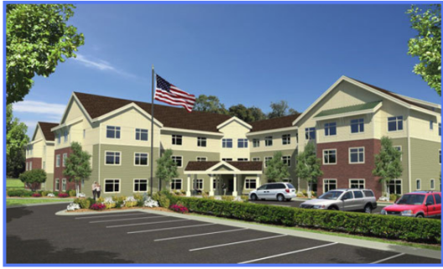
30 June 2019
Start Time Change
Leave Behind Panera 11:30 AM SHARP
Or you may arrive at Benchmark Senior Living, Woburn @ 12:30 PM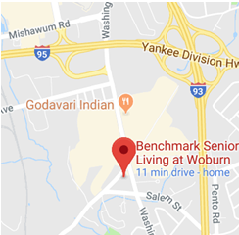
1 Cedar St, Woburn, MA 01801
Benchmark will provide Full Course BBQ until 2:00PM with tents, tables and chairs
Hopefully, there will be a Band at 2:30 PM
Ice Cream Truck will be on hand.
Benchmark Chorus will end the day.
